Creating a Map with Turtlebot

*Make sure ROS_MASTER_URI=http://IP_ADDRESS_OF_TURTLEBOT and ROS_HOSTNAME=IP_ADDRESS_OF_WORK_STATION*

First, run the following 2 terminal commands on the Turtlebot

roslaunch turtlebot_bringup minimal.launch

roslaunch turtlebot_navigation gmapping_demo.launch

‘odom received’ means everything worked properly.

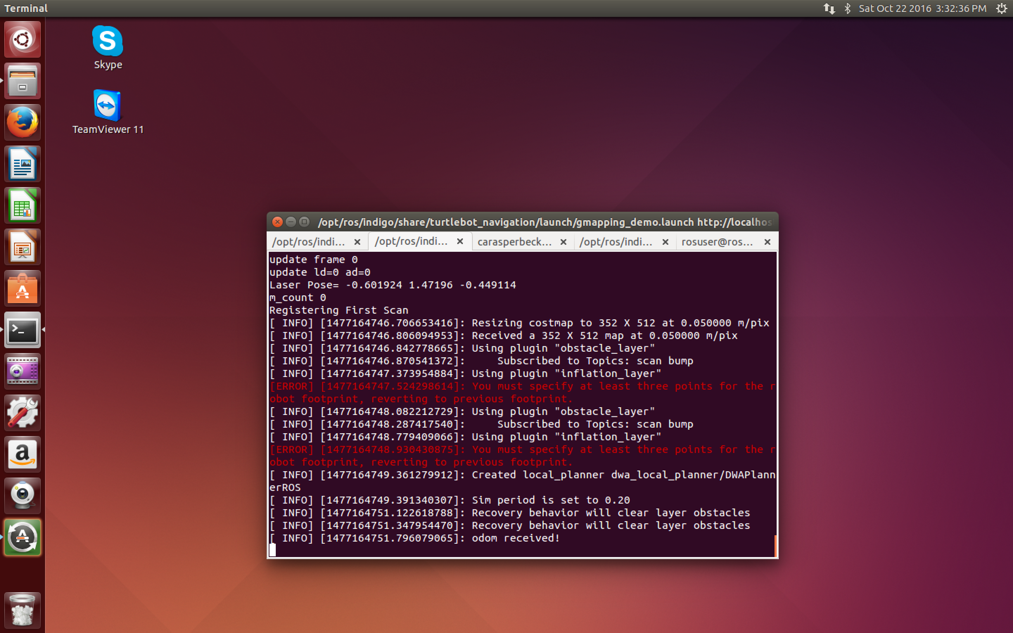

Next, on your workspace run:

roslaunch turtlebot_rviz_launchers view_navigation.launch --screen

This will open RViz. This software will allow the user to see the map that is being created.

Finally, run the following terminal command on the workstation

roslaunch turtlebot_teleop keyboard_teleop.launch

This command will allow the user to drive the Turtlebot around and see the map being created in RViz. The Turtlebot will only move when you are in the terminal window. If you click out into RViz, the Turtlebot will no longer move. Therefore, move the terminal window to the side of the screen so you can still visualize the map being created.

Below are pictures of a map being created. You may need to drive over some parts on the map multiple times while it is being created in order to have the Turtlebot pick up all of the details in the surroundings.

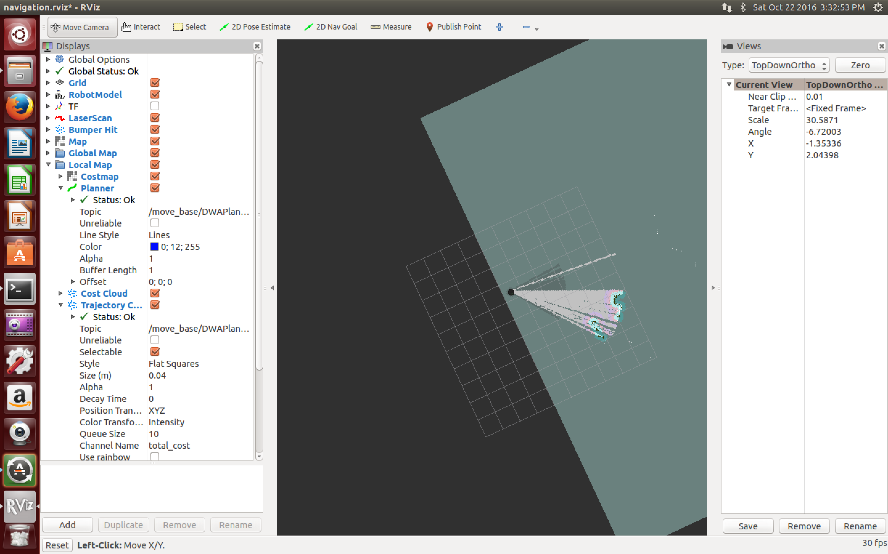

This is what Turtlebot will see initially upon startup. Remember the gmapping software is running and allows this to be seen.

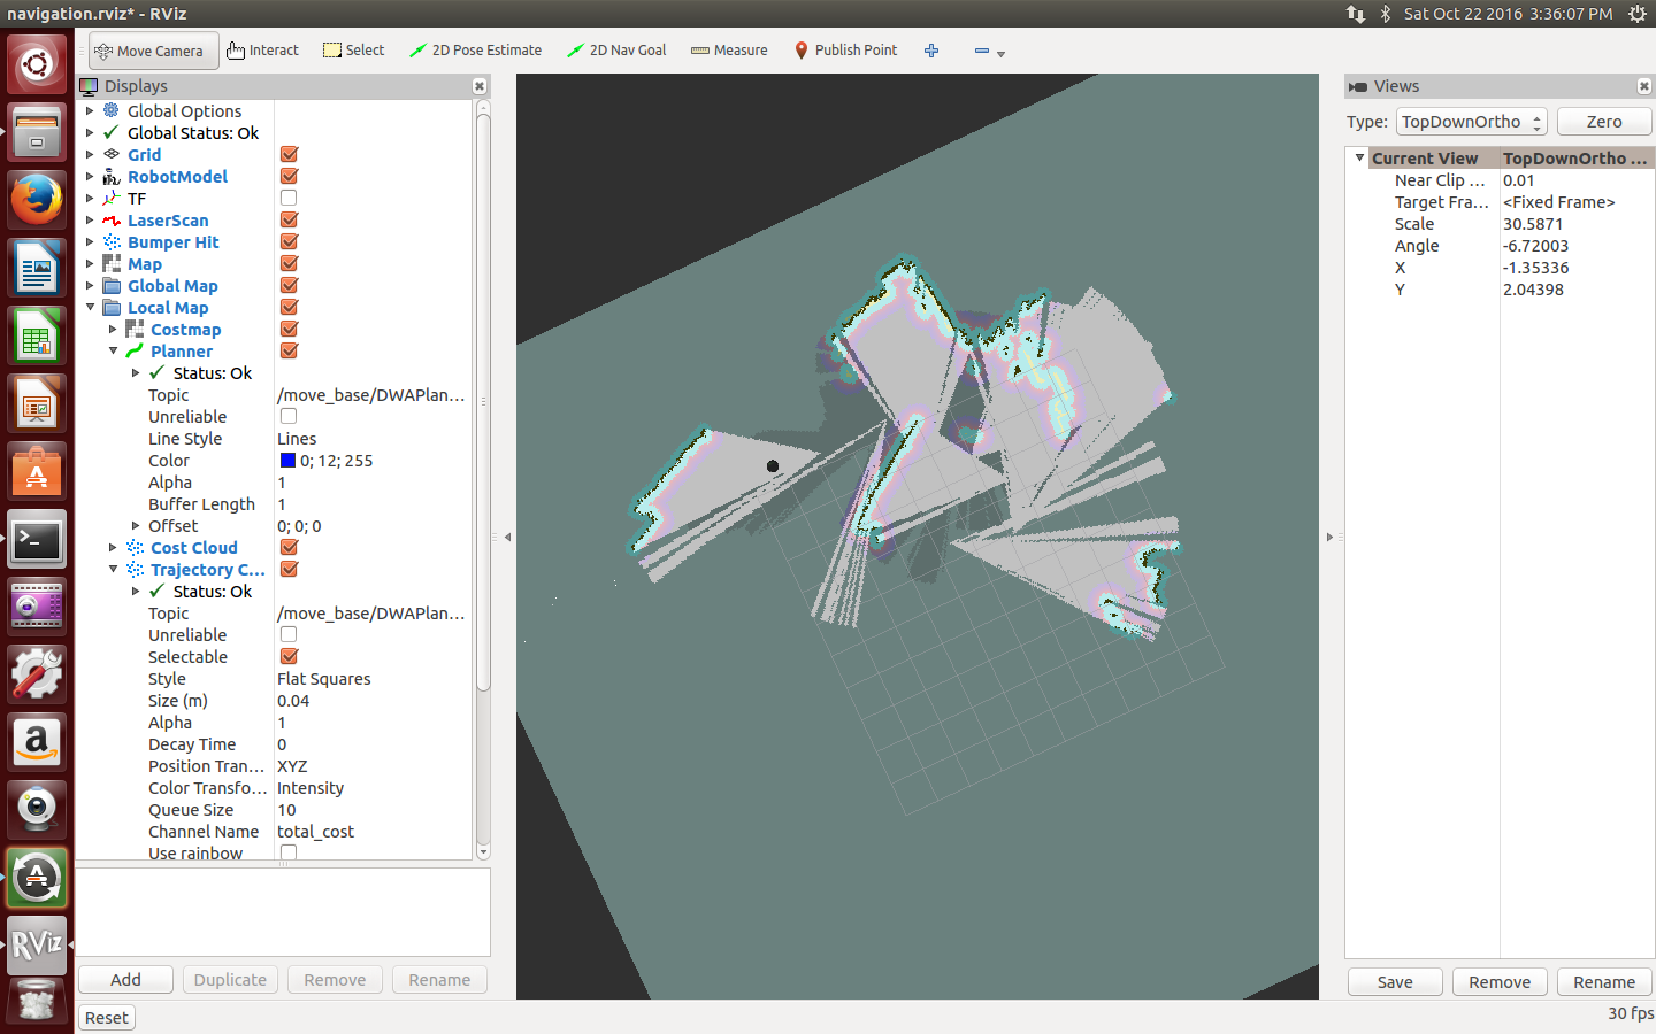

Partway into making the map…

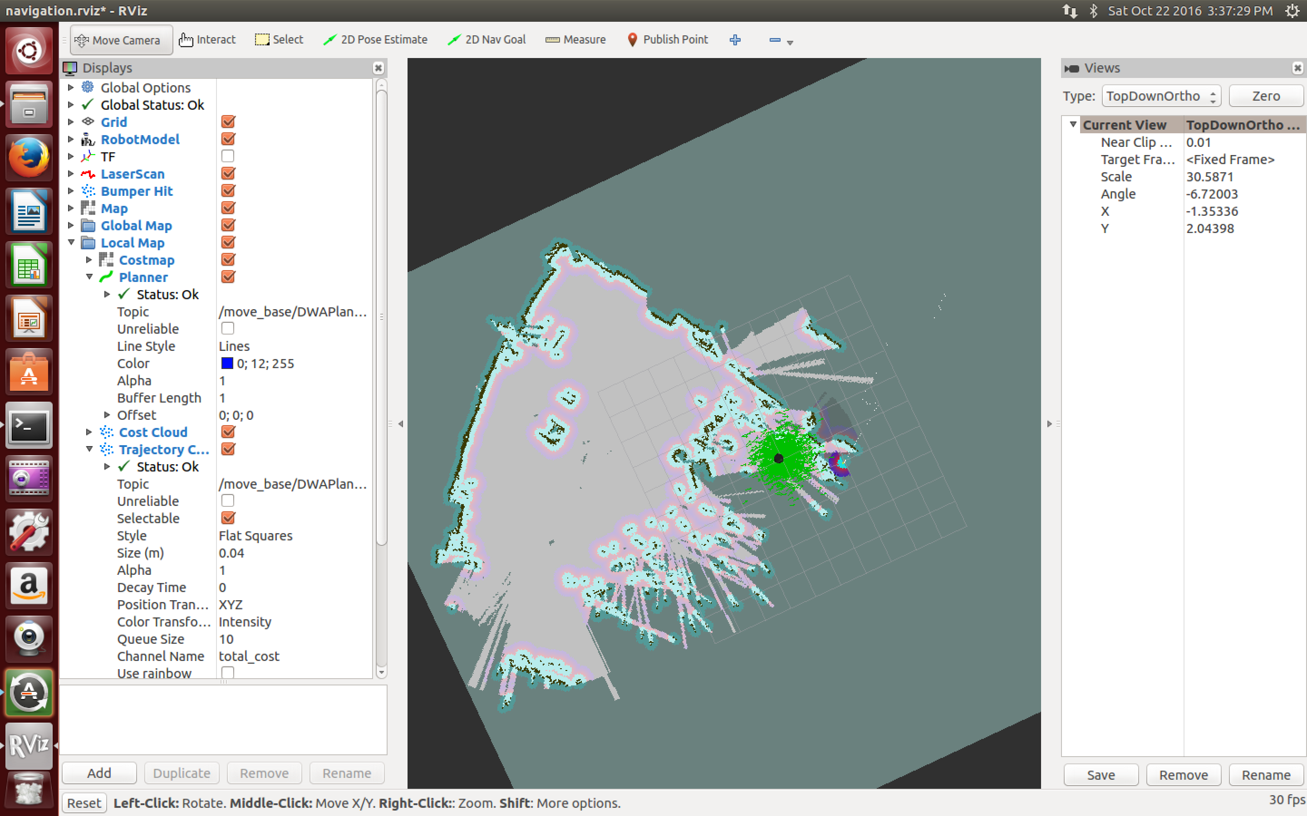

This is a picture of the completed map.

Once you are happy with the map you created, save the map. The map can be saved on either the Turtlebot or the workstation. However, when you load a map in the future, maps will always be loaded from the Turtlebot. Maps do not serve a large purpose on the workstation, therefore always save the map on the Turtlebot. This step is very important because if the map is saved only on the workstation, errors will arise when following future tutorials and trying to load the map on Turtlebot when no map exists on the Turtlebot.

On Turtlebot run the following command in terminal:

rosrun map_server map_saver -f /tmp/my_map_new

*Important: Do not close the gmapping command until the map is saved*

*Important: the tmp folder is temporary! If the computer reboots, everything saved in this folder will be lost. You may want to save the map in a different location or create a backup in a different directory*

On the Turtlebot again, run

ls /tmp

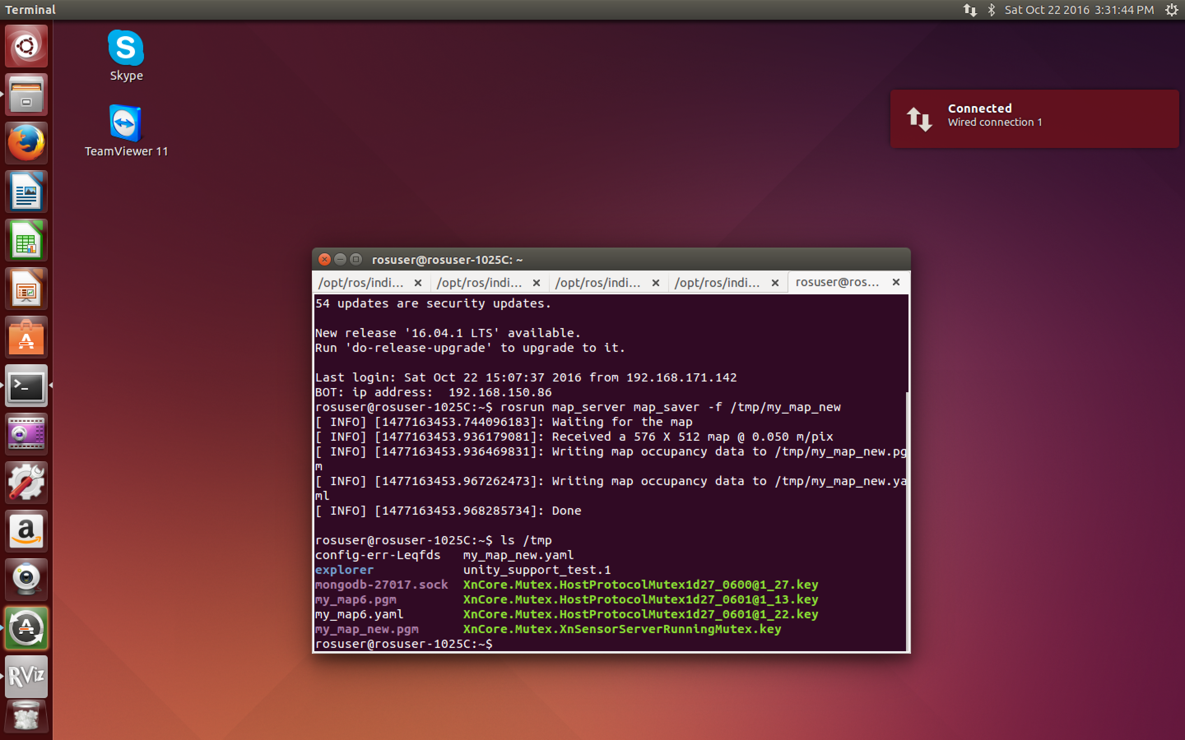

You will now be able to see the map files created for you. You should be able to see a .pgm and a .yaml file. This will be the two files needed for your map.